Network Element DB View

It is required to parse the Network Element details from NEP to create a db view. The two file details will be
Network Element Report
Global SRAN-BS Report
These files will be shared with OmanTel team.

Network Element Report
This document contains the parsed attributes from the Site Component Report in NEP. The attributes include Node Name, Node Type, Node ID, NE Type, Vendor, and Site ID.
Node Name | Node Type | Node ID | NE Type | Vendor | Site ID
NodeA | BTS | 12345 | BTS3900_GSM | Huawei | SITE001
NodeB | IDU | 67890 | RTN380AX | Huawei | SITE002
NodeC | Router | 54321 | ISR4321/K9 | Cisco | SITE003

SS from NEP Site Component Report
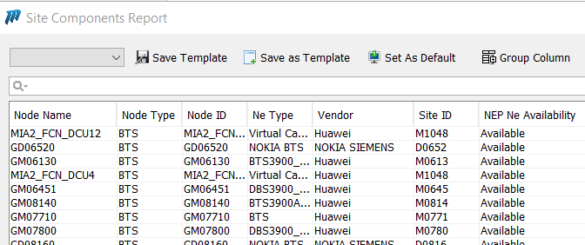

The Node types mentioned below should be excluded in the report.
BONT_Report | Roaming SIM Card Inventory
Cisco call manger (PBX) | Satellite-ODU
Jupiter_HUB | Satellite-License
Optical splitter | MW-ODU
ODF | Satellite-LNB
MiscTraffic | Satellite-Gateway

Note: The Nodes for which attribute NEP NE availability Status is “Available” only need to be added to the db view.

Global SRAN-BSs Report

This document is required to parse the details of SRANBs Node details with its role Nodes from Global SRAN-BSs Report under RAN manager
Below are the attributes.
Object ID | SRAN-BS Name | Site ID | SRAN-BS Type | ENodeB Object ID | ENodeB Name | NodeB Object ID | NodeB Name | BTS Object ID | BTS Name
BM06410 | BM06410 | M0641 | BTS5900 | LM06410 | LM06410 | UM06410 | UM06410 | GM06410 | GM06410
M0480 | M0480 | M0480 | BTS3900A Ver.D | LM04800 | LM04800 | UM04800 | UM04800 | GM04800 | GM04800
B0122 | B0122 | B0122 | BTS3900A Ver.D | LB01220 | LB01220 | UB01220 | UB01220 | GB01220 | GB01220

SS from Global SRAN-BSs Report
